SQL – WORKSHEET 4

## Refer the following ERD and answer all the questions in this worksheet. You have to write the queries using MySQL for the required Operation.

* **Customers**: stores customer’s data.

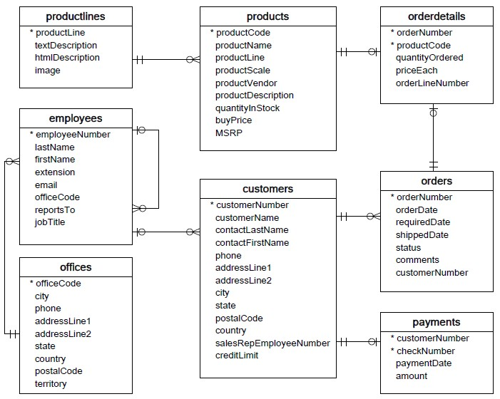

* **Products**: stores a list of scale model cars.
* **ProductLines**: stores a list of product line categories.
* **Orders**: stores sales orders placed by customers.
* **OrderDetails**: stores sales order line items for each sales order.
* **Payments**: stores payments made by customers based on their accounts.
* **Employees**: stores all employee information as well as the organization structure such as who reports to whom.
* **Offices**: stores sales office data.

## QUESTIONS:

1. Write SQL query to show average number of orders shipped in a day (use Orders table).
2. Write SQL query to show average number of orders placed in a day.
3. Write SQL query to show the product name with minimum MSRP (use Products table).

SELECT productName, MSRP

FROM products

WHERE MSRP = (SELECT MIN(MSRP) FROM products);

1. Write SQL query to show the product name with maximum value of stockQuantity.
2. Write a query to show the most ordered product Name (the product with maximum number of orders).
3. Write a SQL query to show the highest paying customer Name.
4. Write a SQL query to show cutomerNumber, customerName of all the customers who are from Melbourne city.

SELECT customers.customerName, customers.customerNumber, customers.city FROM customers WHERE city=Melbourne.city;

1. Write a SQL query to show name of all the customers whose name start with “N”.

SELECT * FROM customers WHERE customerName LIKE 'D%';

1. Write a SQL query to show name of all the customers whose phone start with ‘^7.*’ and are from city ‘Las Vegas’.
2. Write a SQL query to show name of all the customers whose creditLimit < 1000 and city is either “Las Vegas” or ”Nantes” or “Stavern”.
3. Write a SQL query to show all the orderNumber in which quantity ordered <10.
4. Write a SQL query to show all the orderNumber whose customer Name start with letter **N.**



1. Write a SQL query to show all the customerName whose orders are “Disputed” in status.
2. Write a SQL query to show the customerName who made payment through cheque with checkNumber starting with **H** and made payment on “2004-10-19”.
3. Write a SQL query to show all the checkNumber whose amount > 1000.